Healthcare Appointment No-Show Analytics using Snowflake
Business Scenario
A hospital network wants to analyze patient appointment behavior.
The hospital wants to know:
How many appointments are booked?
How many patients miss their appointments?
Which age group has the highest no-show rate?
Does SMS reminder reduce no-show?
Which neighborhood has more missed appointments?
How can Snowflake automatically load new appointment files?
How can Power BI show the final dashboard?
You are asked to build a Snowflake data pipeline from raw CSV data to a clean reporting table.

Part A: Assignment Questions for Students
Task 1: Create Snowflake Objects
Create:

Warehouse
Database
Schema
File format
Internal stage

Use the name:
HEALTHCARE_WH
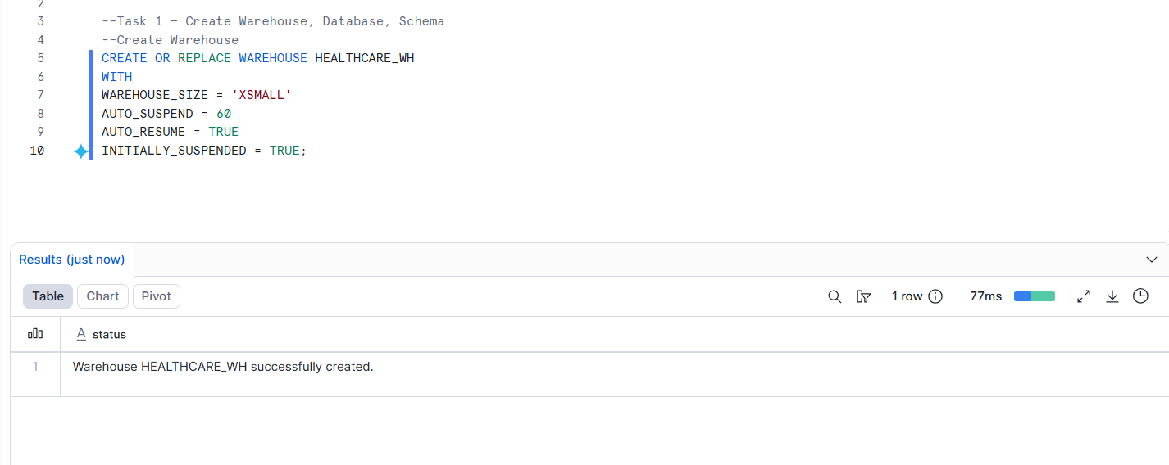
HEALTHCARE_DB
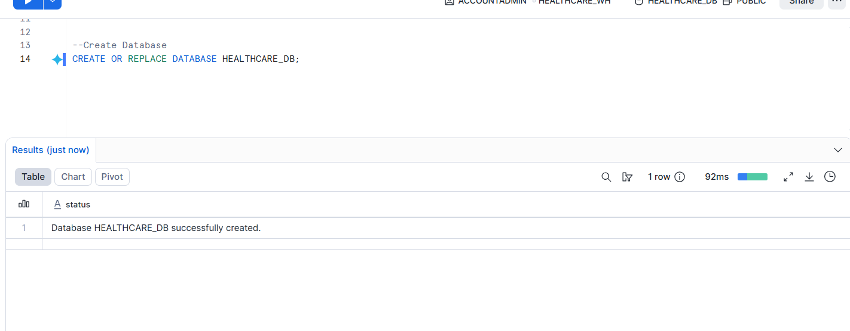
APPOINTMENT_SCHEMA
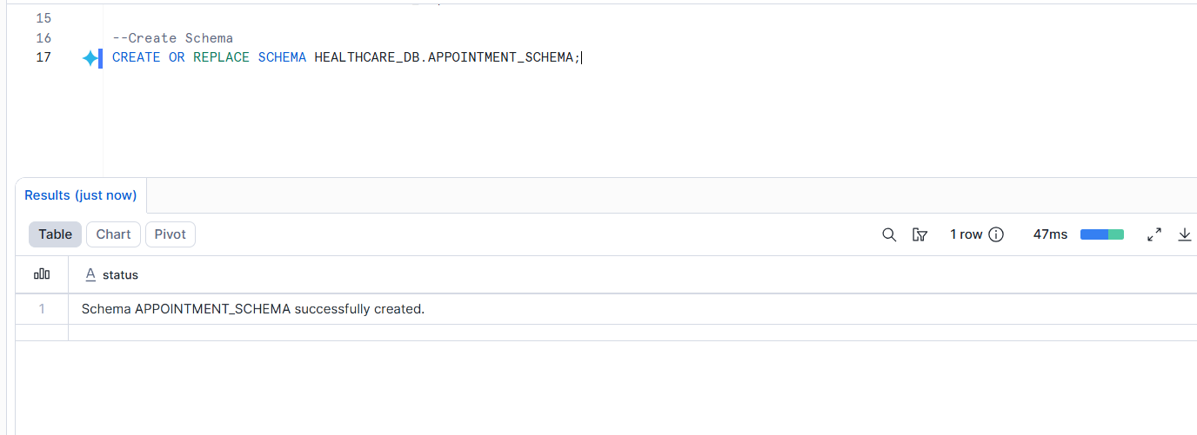

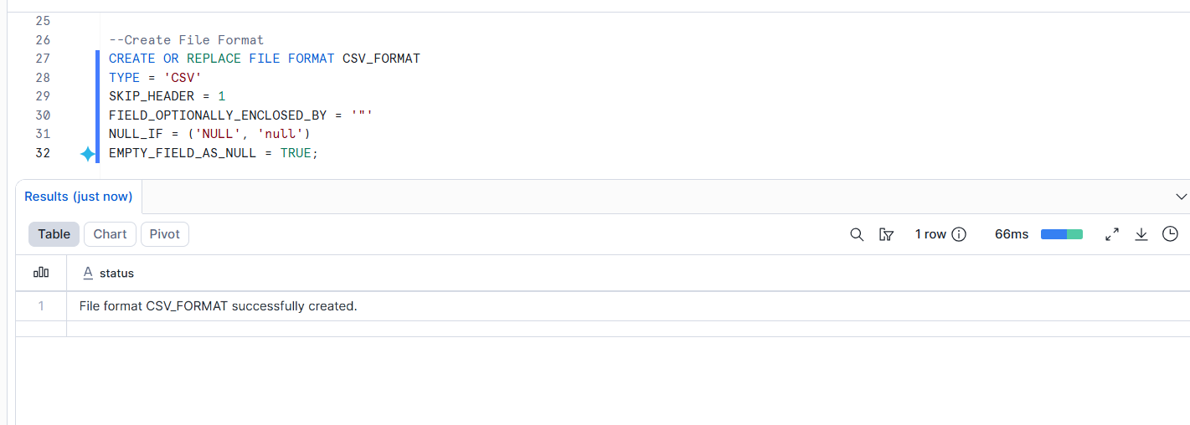

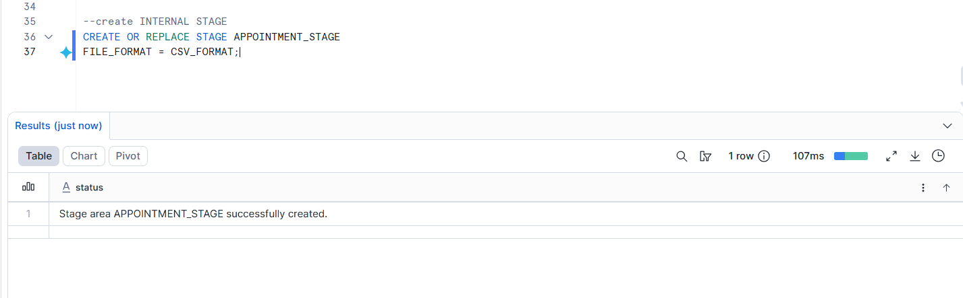
Task 2: Scale Warehouse Up and Down
Perform the following:
Create warehouse as XSMALL


Scale it up to SMALL
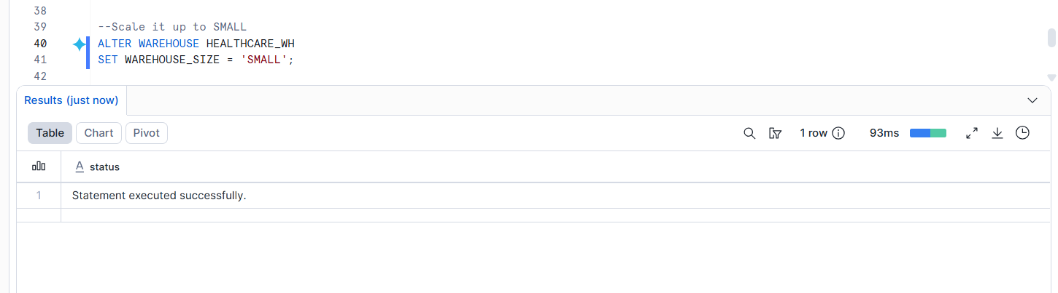
Scale it down again to XSMALL
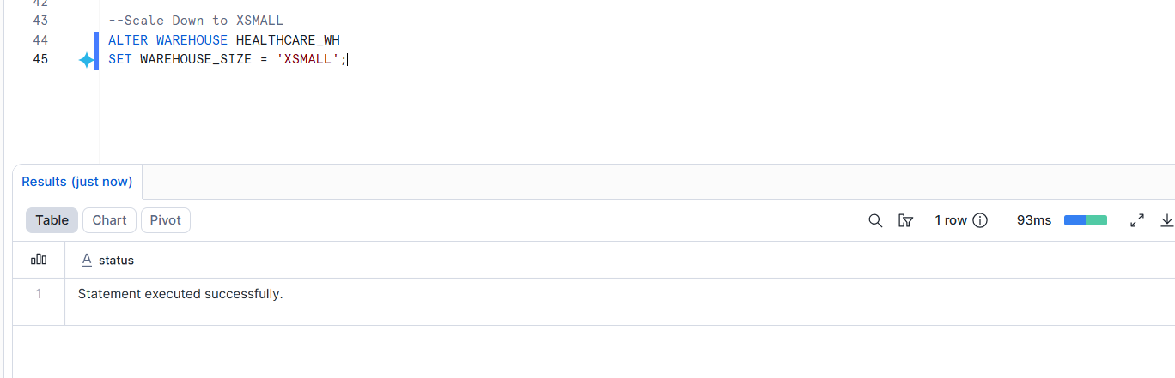
Suspend the warehouse manually
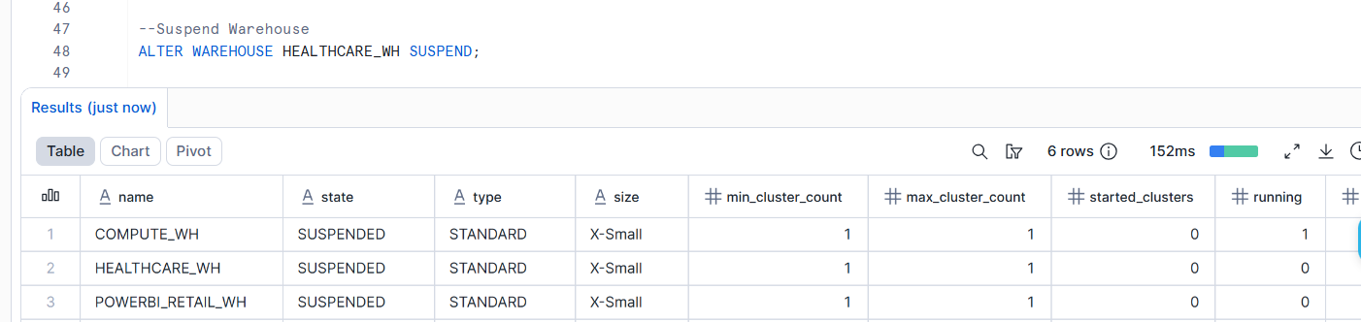
Resume the warehouse manually
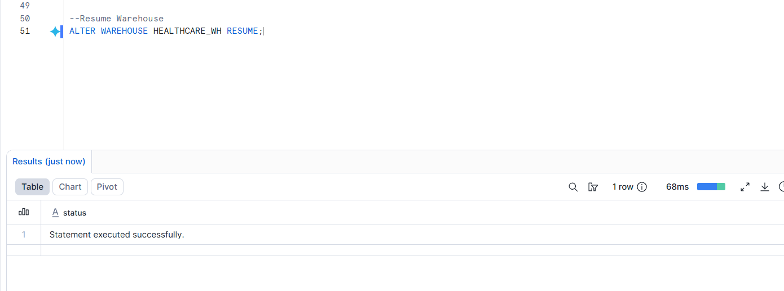

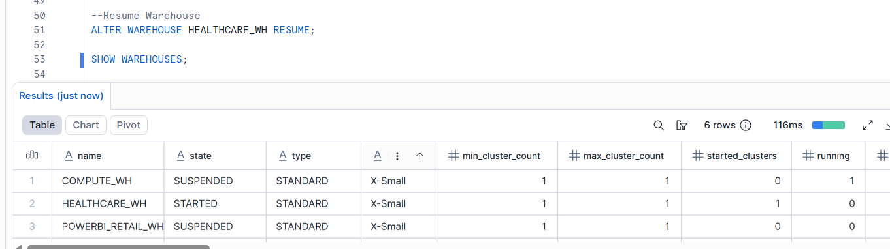

Task 3: Download Dataset from Open URL

Use this public CSV dataset:
https://raw.githubusercontent.com/kb22/Medical-Appointment-No-Show-Prediction/master/data/dataset.csv
Download the CSV file to your local system.
File name:
appointment_no_show.csv
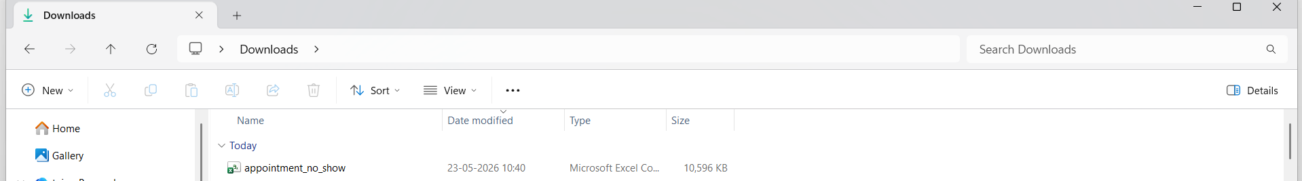

Task 4: Upload CSV into Snowflake Stage

Upload the CSV file into Snowflake internal stage using Snowsight.
Stage name:
APPOINTMENT_STAGE
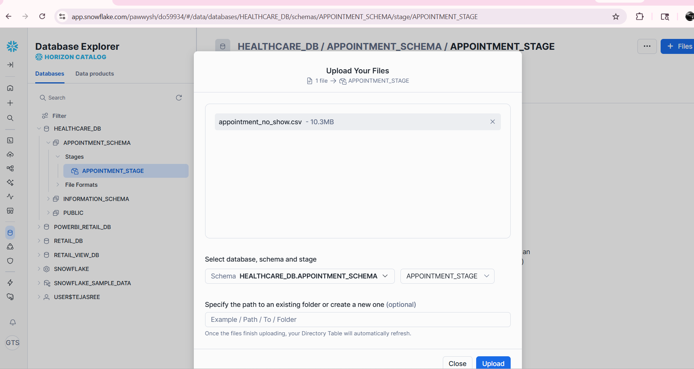

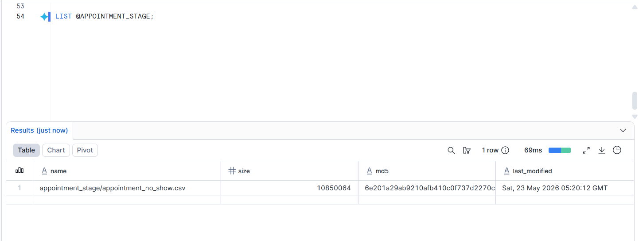

Task 5: Create Raw Table
Create a raw table to store CSV data exactly as received.
Table name:
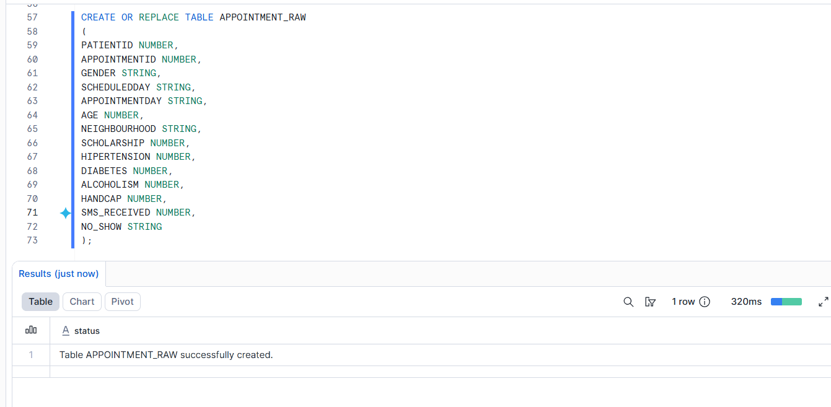

APPOINTMENT_RAW
Task 6: Load Data from Stage to Raw Table

Use COPY INTO to load staged CSV data into the raw table. Snowflake COPY INTO <table> loads staged files into a table using the selected file format.

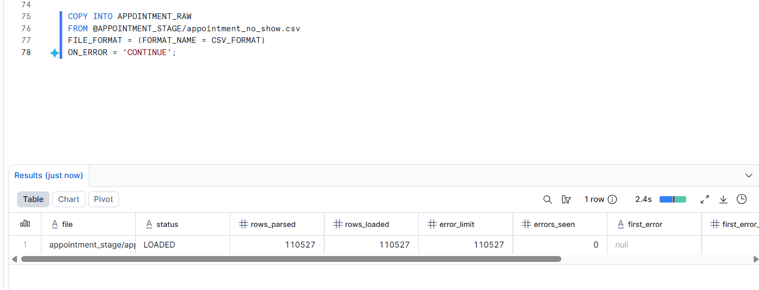

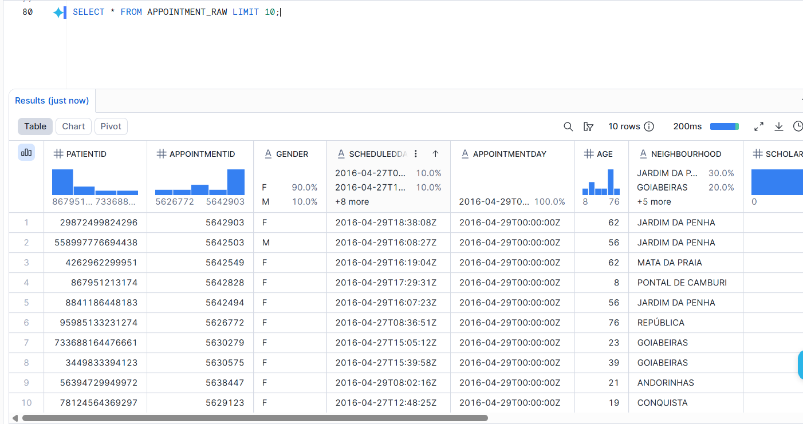

Task 7: Create Final Table

Create a transformed final table:

APPOINTMENT_FINAL
The final table should include:

Patient ID
Appointment ID
Gender
Age
Age group
Scheduled date
Appointment date
Waiting days
Neighborhood
Scholarship
Hypertension
Diabetes
Alcoholism
Handicap
SMS received
No-show status
Attendance status
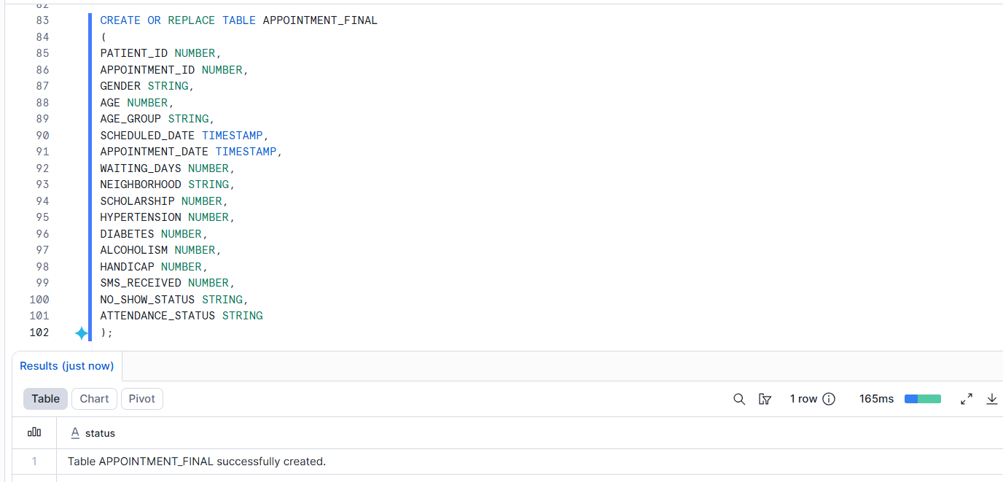

Task 8: Use Snowpark Python

Create a Snowpark Python stored procedure to transform data from raw table to final table.
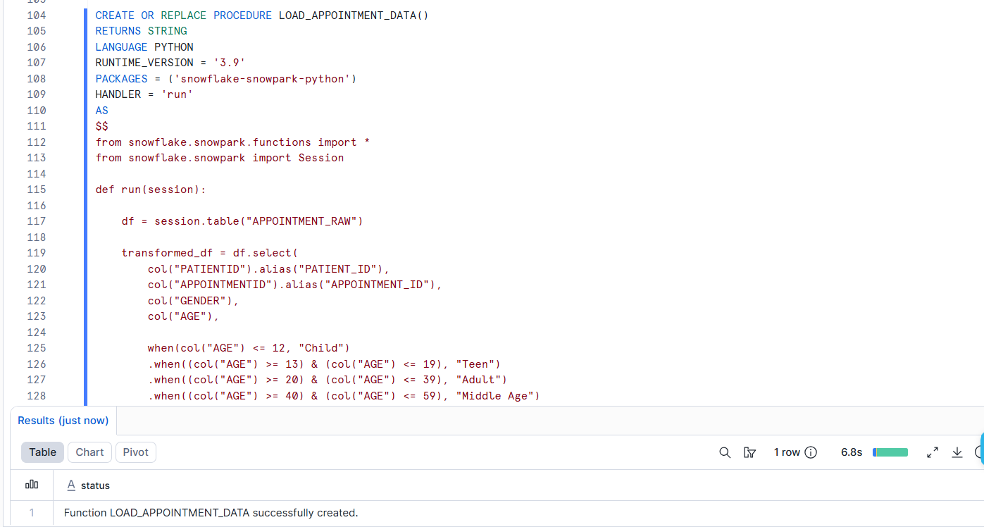
Snowpark Python procedures can run Python logic inside Snowflake and perform queries, updates, and transformations on Snowflake tables.
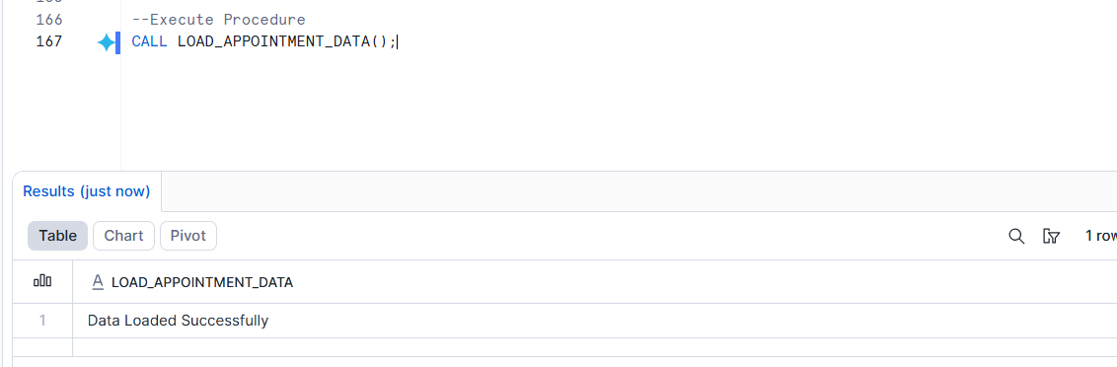

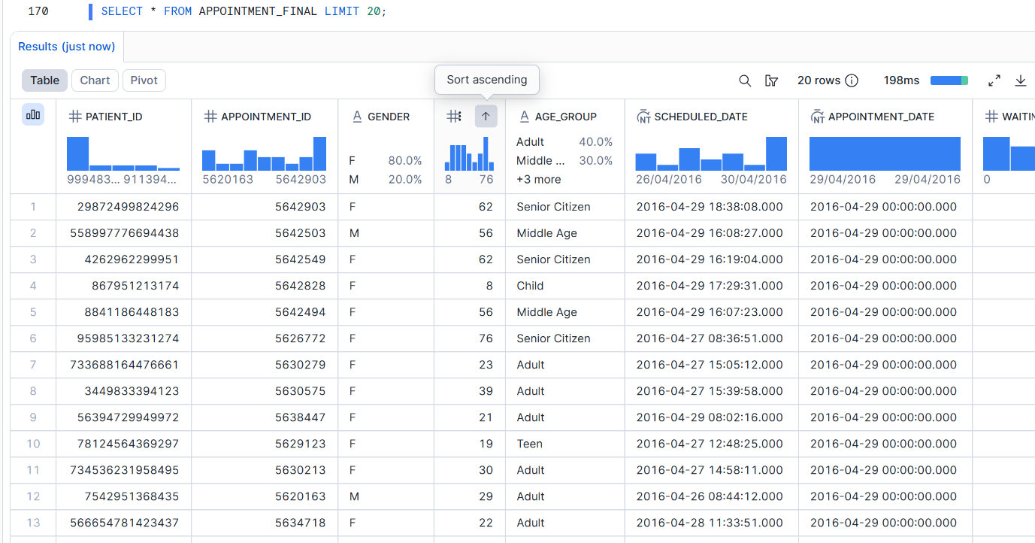
Task 9: Create Stream

Create a stream on the raw table to track newly inserted rows.
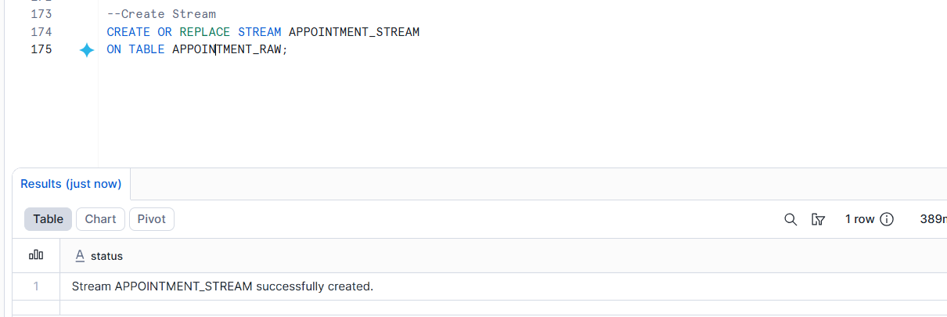
A Snowflake stream tracks row-level changes in a source table between transactional points, which is useful for change data capture.
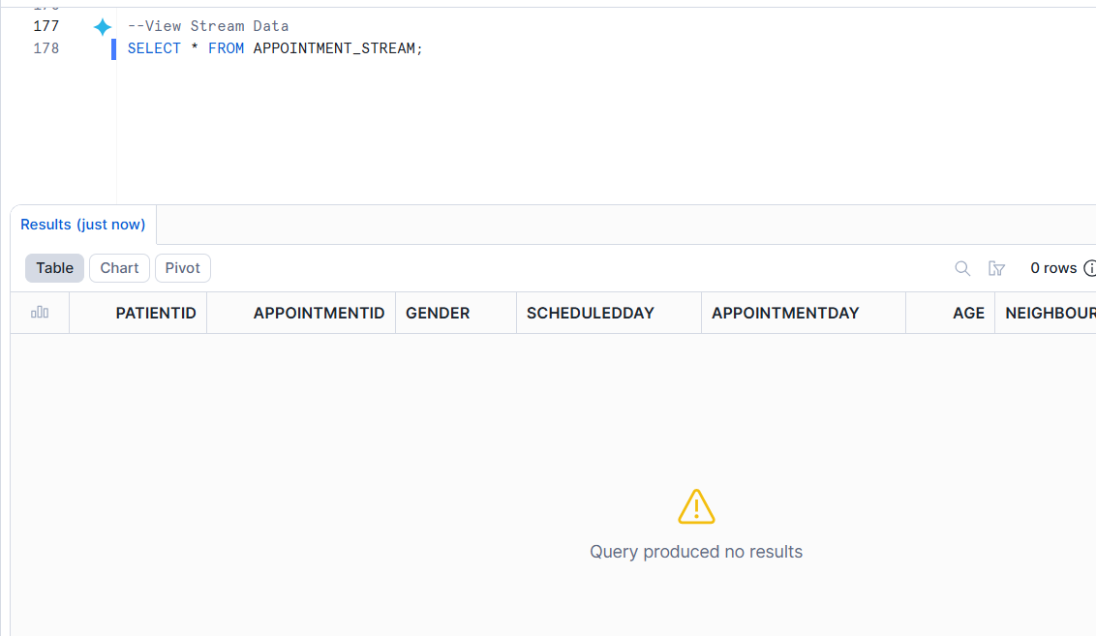
Task 10: Use Stream for Incremental Loading

Insert new records into the raw table.
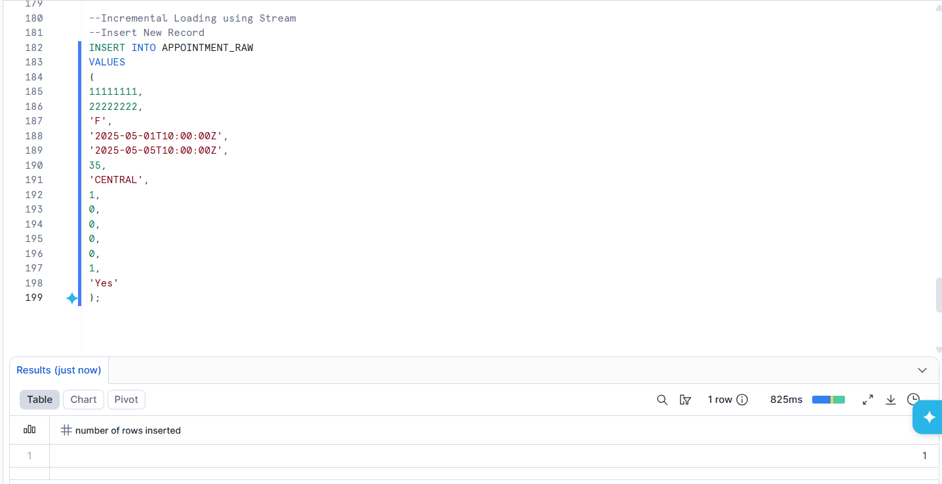

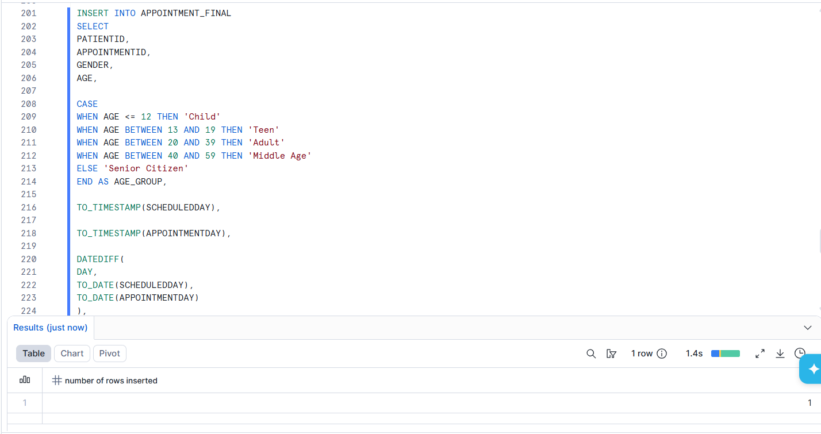

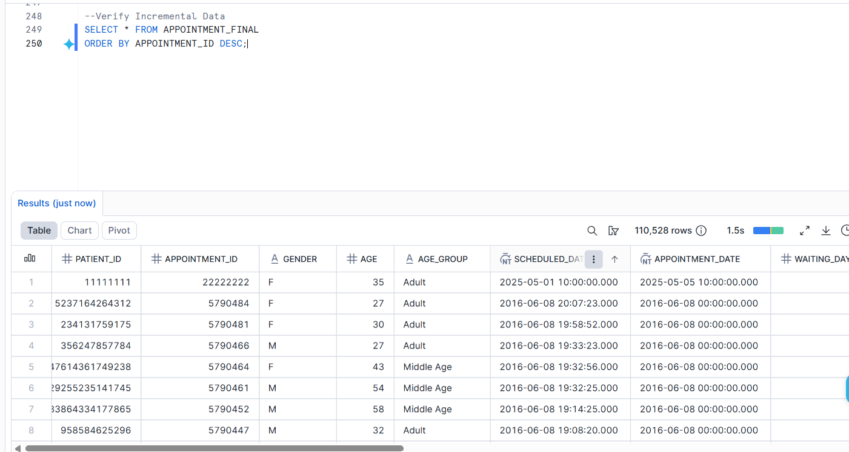
Then use the stream to load only new records into the final table.

Task 11: Create Snowpipe
Create a Snowpipe pipe to load new CSV files from the stage into the raw table.
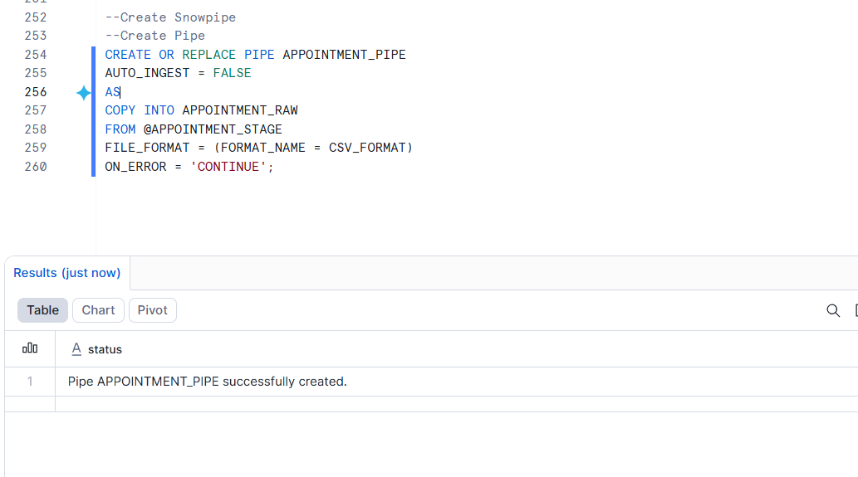
Snowpipe loads files as soon as they are available in a stage, using a pipe object that contains a COPY INTO statement.
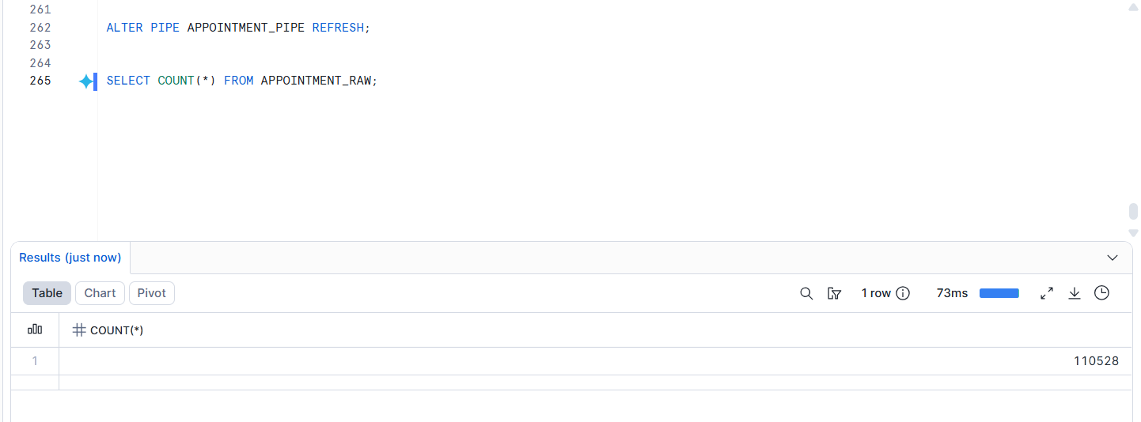

Task 12: Create Reporting View

Create a view for Power BI:

VW_APPOINTMENT_DASHBOARD
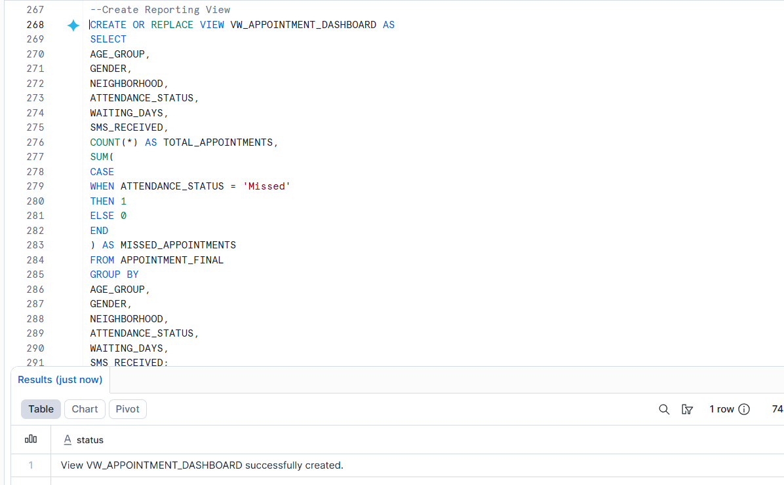
Task 13: Connect Snowflake with Power BI

Connect Power BI Desktop to Snowflake and create a dashboard.

Dashboard title: Healthcare Appointment No-Show Dashboard
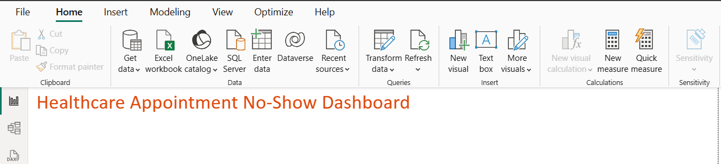

Create these DAX measures.

Total Appointments
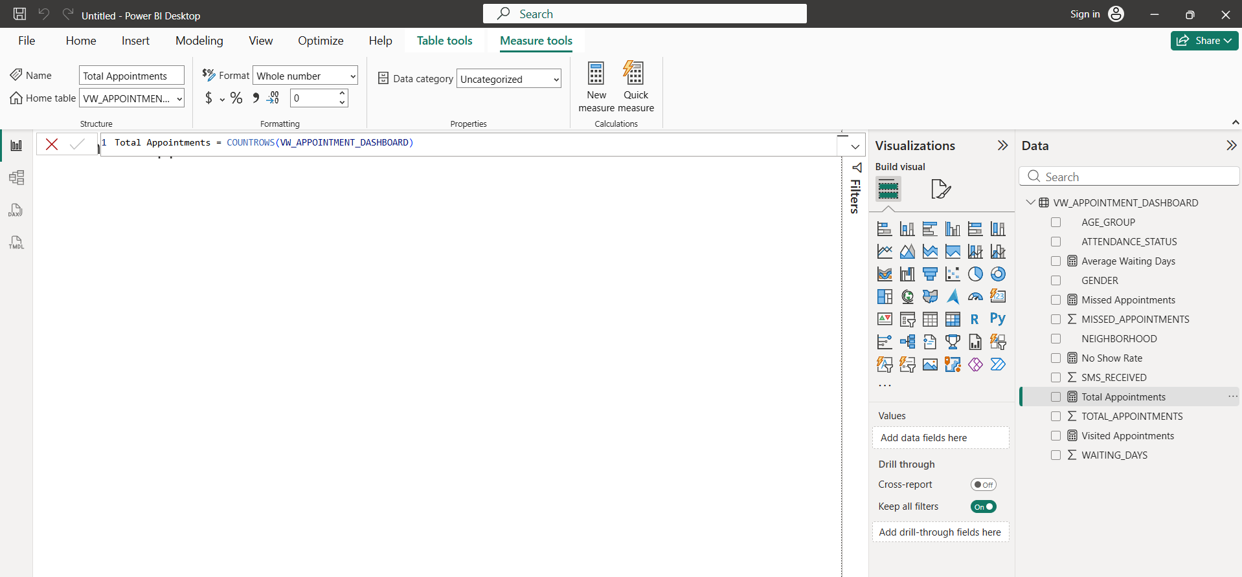
Missed Appointments
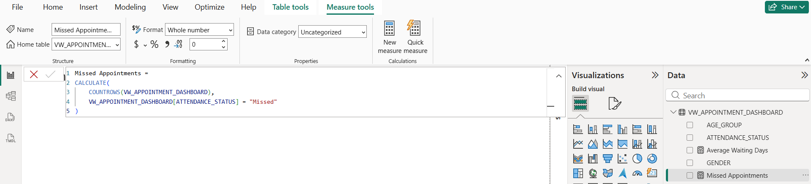
Visited Appointments
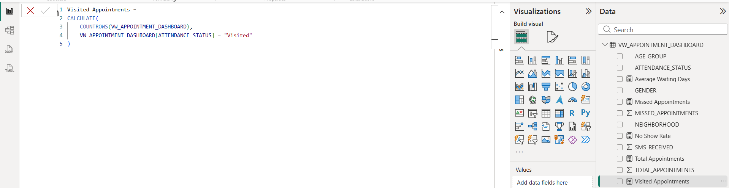

No Show Rate
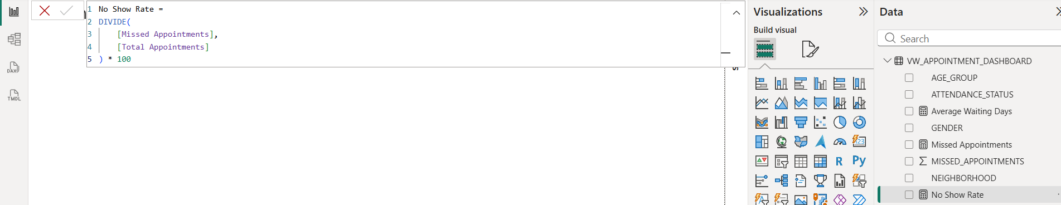
Average Waiting Days
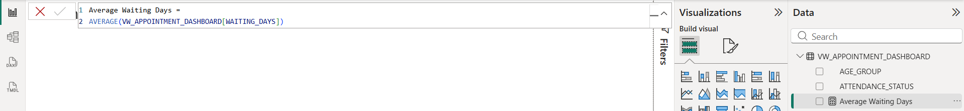

Attendance Status Distribution -> Donut Chart
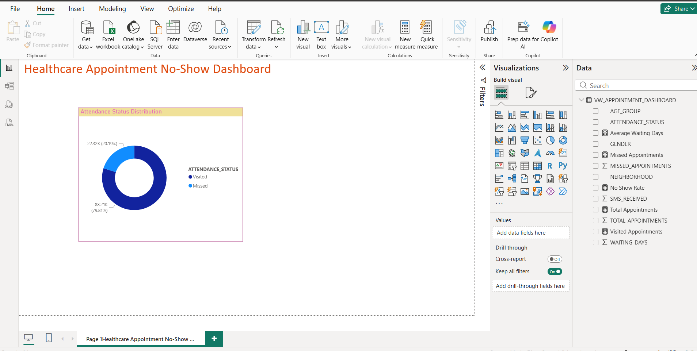

No-Show by Age Group -> Clustered Column Chart
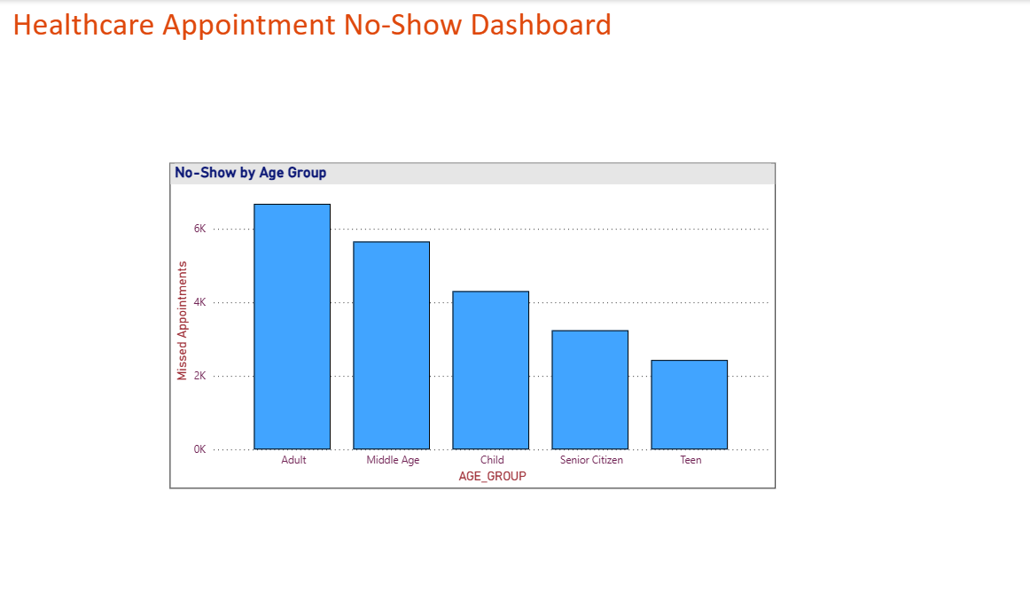

Healthcare Appointment No-Show Dashboard
